

**Semester One Examination 2019**

**Question/Answer Booklet**

**PHYSICS**

**UNIT 1**

Answer Key

**Time allowed for this paper**:

Reading time before commencing work: 10 minutes

Working time for paper: 3 hours

**Materials required/recommended for this paper**

***To be provides by the supervisor***

This Question/Answer Booklet

Formulae and Data Booklet

***To be provided by the candidate***

Standard items: pens, pencils (including coloured), sharpener, correction fluid, eraser, ruler, highlighters.

Special items: up to three non-programmable calculators approved for use in the WACE examinations, drawing templates, drawing compass and a protractor.

**STRUCTURE OF THIS PAPER**



|  |  |  |  |  |  |  |
| --- | --- | --- | --- | --- | --- | --- |
| **Section** | **No. of**  **Questions** | **No. of questions**  **to be attempted** | **Suggested working time**  **(minutes)** | | **Marks available** | **Percentage of**  **exam** |
| Section one  Short Response | 11 | ALL | 50 | | 54 | 30 |
| Section two  Problem Solving | 6 | ALL | 90 | | 90 | 50 |
| Section three  Comprehension | 2 | ALL | 40 | | 36 | 20 |
| Total | **180** | **100** |

**INSTRUCTIONS TO CANDIDATES**

Write your answers in the spaces provided beneath each question. The value of each question (out of 180) is shown following each question.

Answers to questions involving calculations should be evaluated and given in decimal form. Final answers should be given up to three significant figures and include appropriate units.

Questions containing the instruction "**estimate**" may give insufficient numerical data for their solution. Give final answers to a maximum of two significant figures and include appropriate units.

Despite an incorrect final result, credit may be obtained for method and working providing these are clearly and legibly set out.

Questions containing specific instructions to **show working** should be answered with a complete, logical, clear sequence of reasoning showing how the final answer was arrived at; correct answers which do not show working will not be awarded full marks.

**Section One: Short Response 30% (54 marks)**

This section has 11 questions. Answer **all** questions. Answer the questions in the spaces provided.

Suggested working time: 50 minutes.

**Question 1 (3 marks)**

Aiden is measuring the following shaded perfect circle and he puts a ruler next to it, as shown on the right.

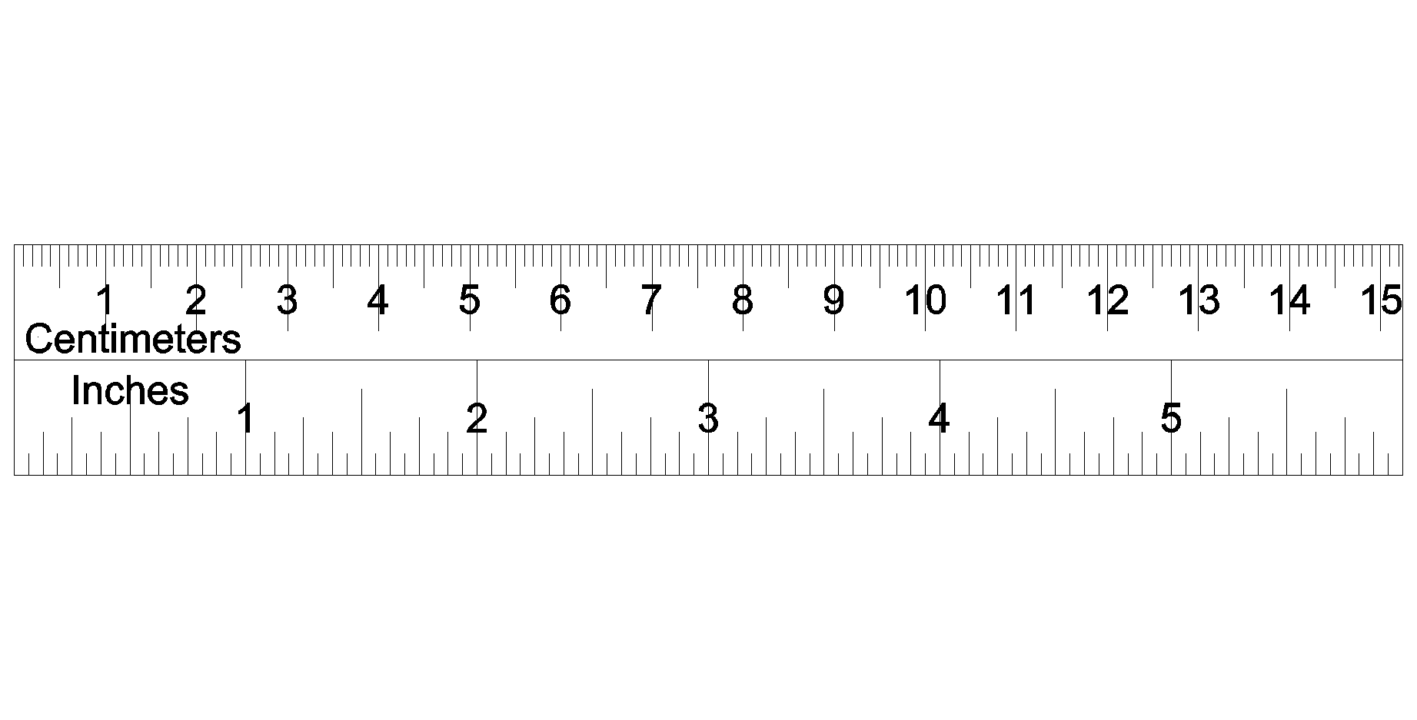

Write the absolute and relative uncertainties of the diameter of the circle below.

Diameter with absolute uncertainty:

2.70 cm ± 0.05 cm (or 0.1 cm) ✓✓

Diameter with relative uncertainty:

2.70 cm ± 1.9 % (or 3.7%) ✓

Space for working out:

$\frac{0.05}{2.7}×100=1.85\%$

Note: Teachers are welcome to remove the rule from the diagram.

**Question 2 (3 marks)**

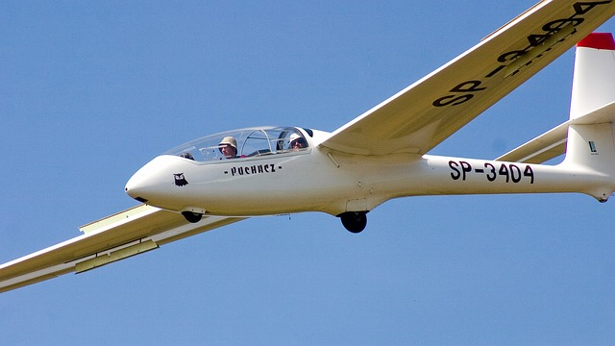

A glider, as shown on the right, is a light aircraft that is designed to fly without using an engine over a large plain field. As the field is heated by the sun, it is able to operate more effectively. Explain the reasons using Physics concepts.

* The hot ground radiates heat and warms the air above it. ✓
* This causes the reduction of air density.

Warm air then rises (convection current). ✓

* This provides an additional upward force to the glider so that it

remains in the air. ✓

**Question 3 (5 marks)**

Sodium-24 has a half-life of 15.0 hours. It has applications in medicine and engineering.

1. How much of a 34.0 g sample of Sodium-24 will remain undecayed after two days? Show clear working. (3 marks)

* Time is in hours: ✓

* Decay calculation ✓

* Answer = 3.70 g ✓

1. If Iodine-131 (half-life = 8.00 days) of the same amount were to replace Sodium-24, would more of the original sample be left over or less compared to Sodium-24? Explain without calculations. (2 marks)

* More. ✓
* The half-life of iodine-131 is longer, that means it

decays slower than sodium-24. ✓

**Question 4 (4 marks)**

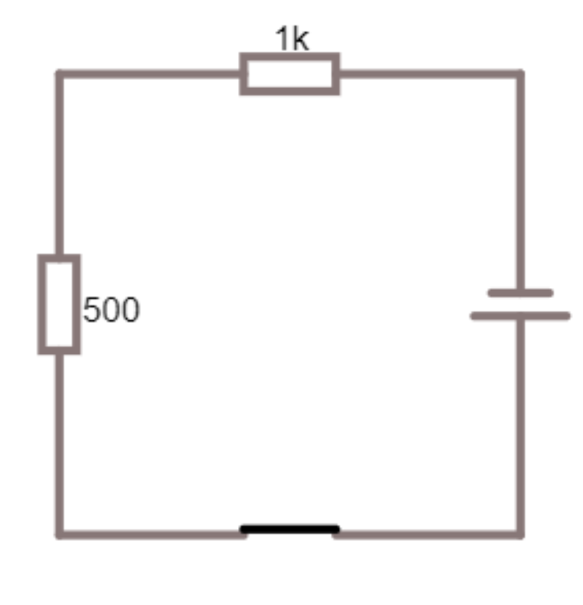The circuit on the right consists of a switch, two resistors (1.00 kΩ and 500 Ω) and a 12.0 V battery.

1. In the diagram, label the direction of the flow of electrons. (1 mark)

*i* ✓

1. A student is about to measure the voltage drop across the 1.00 kΩ resistor using a voltmeter. What is the expected reading? Show your calculation. (3 marks)

* Total resistance: ✓

Closed Switch

$R_{T}=1000+500=1500Ω$

* Main current calculation: ✓

* Voltage drop: ✓
* Answer V = 8.00 V

**Question 5 (7 marks)**

A food shop sells hot beef soup. A number of slices of beef are put into a bowl, followed by pouring in a hot liquid vegetable stock. The soup is then ready to serve to customers.



Use the following information to answer the questions:

* Mass of vegetable stock: 0.800 kg
* Initial temperature of the stock: 96.0 oC
* Specific heat capacity of the stock: 4000 J kg-1 K-1
* Mass of each beef slice: 50.0 g
* Initial temperature of beef: 6.00 oC
* Specific heat capacity of beef: 3000 J kg-1 K-1

1. According to safety regulations, the serving temperature of the soup should be below 60.0 oC. Estimate the minimum number of beef slices required to add to the stock to achieve this.

(6 marks)

* Setup for heat loss: ✓
* Setup for one slice of beef (heat gain): ✓
* Qgain = Qloss ✓
* Calculation of number of slices of beef: ✓✓
* Answer: at least 15 slices. ✓

1. State one assumption in the calculation in part a). (1 mark)

* Assuming no energy is lost to the environment. ✓

**Question 6 (7 marks)**

The diagram below shows a neutron being absorbed by a Uranium-235 atom. The remaining neutrons then continue to react with other Uranium-235 atoms.

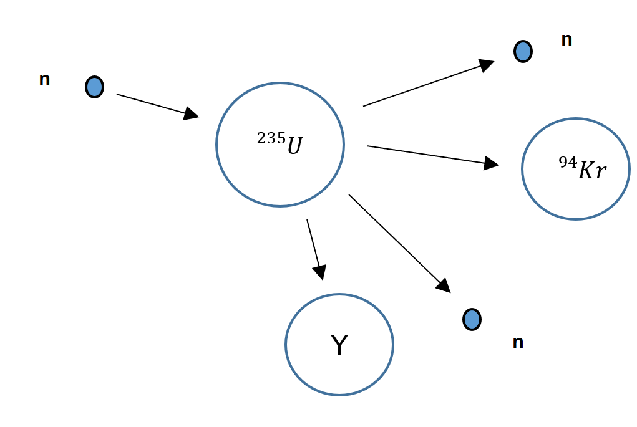

1. Complete the following table by writing the correct terminologies: (3 marks)

|  |  |
| --- | --- |
| **Descriptions** | **Terminologies** |
| A neutron collides with a Uranium nucleus and is absorbed. | Neutron capture ✓ |
| The atom splits into different two atoms and two neutrons. | Fission ✓ |
| The released neutrons continue to be absorbed by other Uranium-235 nuclei. | Chain reaction ✓ |

1. Predict what substance **Y** be. Write the symbol of the substance, its atomic number and mass number in a correct format. (2 marks)

✓✓

1. The Krypton-94 continues to decay and release a beta negative particle. Write the full nuclear equation for this decay. (2 marks)

✓✓

**Question 7 (5 marks)**

The diagram below is a simple schematic diagram of a fridge. It consists of one long coil that goes through the inside compartment of the fridge and then flows outside. Fluid refrigerant is sealed inside this coil. The arrow, in the diagram below, shows the direction of the refrigerant. Part C is called an expansion valve. The pressure inside the pipe is reduced by the expansion valve, causing the refrigerant to evaporate.

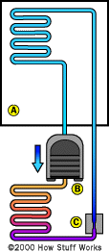

1. Explain how this helps to cool the fridge. (3 marks)

* As the refrigerant evaporates, turning from liquid to gas. ✓

It then absorbs energy from the surrounding. ✓

* This allows the heat to be removed from the air so

it becomes cooler. ✓

1. When there is a power outage, a fridge can still keep the contents cold for as long as 2 hours. Describe the features of a fridge which help to keep the fridge cold. (2 marks)

* A fridge is made of insulators. ✓
* Sealed shut to prevent heat coming from outside. ✓
* Hollow doors to prevent conduction while silver to reflect OR radiation.

(any two features relate to conduction, convection and radiation)

**Question 8 (6 marks)**

A heating coil is rated at 2.00 kW when 8.00 A flows through it. When the heater has been turned on for 1.00 hour, calculate:

1. the potential difference across the heater. (2 marks)

* Calculation: ✓
* Answer: V = 250 V ✓

1. the total amount of charge that has flowed through the heater during its operation. (4 marks)

* time in seconds: ✓

* Calculation: ✓
* Answer: Q = 28800 C ✓ correct unit ✓

**Question 9 (5 marks)**

The graph below shows the decay of radioactive substance **Z**.

1. Use the graph above to estimate the half-life of substance **Z**. Show your working on the graph above. (2 marks)

* Approximately 1.7 minutes. (± 0.1 min) ✓
* Show working out on the graph. ✓

1. Hence, estimate how long it would take for substance **Z** to decrease to 10.0 Bq of activity. (3 marks)

**Option 1 Using systematic method**

* Setup ✓

450 🡪 225 🡪 112.5 🡪 56.25 🡪 28.125 🡪 14.0625 🡪 7.03125

* Number of half-lives ✓

Total 6 half-lives

* Calculation of total time

t = 6 x 1.7 = 10.2 minutes

* Answer: t = 10 minutes ✓

**Option 2 Using calculation**

* Setup ✓

* Solving ✓
* Answer: t = 9.3 minutes ✓

**Question 10 (5 marks)**

Find the binding energy, per nucleon in, MeV, for Uranium-236.

Use the following data:

Mass of proton = 1.00727 u

Mass of neutron = 1.00867 u

Mass of Uranium-236 = 236.045568 u

* Number of protons and neutrons: ✓

p = 92 n = 144

* Mass of total nucleons: ✓
* Difference of mass: ✓
* Converting energy to MeV ✓
* Energy per nucleon ✓
* Answer = 7.38 MeV per nucleon.

**Question 11 (4 marks)**

Calculate how much energy needs to be removed to convert 500 g of water from 24.0 oC into ice at –4.00 oC ice.

* Heat removed between 0 and 24 oC ✓
* Heat removed in latent heat ✓
* Heat removed between – 4 and 0 oC ✓
* Total heat to be removed ✓
* Answer Q = 2.21 x 105J

**END OF SECTION ONE**

**Section Two: Problem-solving 50% (90 marks)**

This section contains 6 questions. Answer **all** questions. Answer the questions in the spaces provided.

Suggested working time 90 minutes.

**Question 12 (16 marks)**

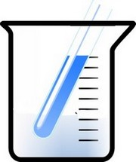John carries out an experiment to investigate the cooling properties of

Octadecan-1-ol. Octadecan-1-ol is one type of alcohol that can be used in anti-freeze products and lubricants. Its latent heat of fusion is 331 J kg-1.

John heats a test tube containing of 250 g solid Octadecan-1-ol in a water bath at 80.0 oC. He then puts the test tube immediately into a beaker of iced water.

The temperature of the Octadecan-1-ol is then recorded over a time interval of 5.00 minutes. The results are shown below:

|  |  |  |  |  |  |  |  |  |  |  |  |
| --- | --- | --- | --- | --- | --- | --- | --- | --- | --- | --- | --- |
| **Time (s)** | 0 | 30 | 60 | 90 | 120 | 150 | 180 | 210 | 240 | 270 | 300 |
| **Temperature (oC)** | 71 | 63 | 57 | 55 | 55 | 55 | 55 | 55 | 50 | 44 | 35 |

1. Plot a cooling curve of Octadecan-1-ol in the graph below. A spare graph paper can be found on page 30.

(2 marks)

* Accuracy of data ✓✓
* Axes with units ✓

1. Estimate the melting point of Octadecan-1-ol, in Kelvin. (2 marks)

* 55 oC ✓
* Answer = 330 K ✓ (2sf)

1. Use kinetic particle theory to explain the shape of the curve between 90 seconds and 210 seconds.

(3 marks)

* Particles get closer together. ✓

i.e. it loses energy.

* Therefore, potential energy is decreased. ✓
* Kinetic energy remains constant. ✓

1. Use the given information to calculate the rate of heat loss of the 250 g of Octadencan-1-ol in between 90 seconds and 210 seconds. (4 marks)

* Time t = 120 s ✓
* Heat absorbed ✓
* Power calculation ✓
* Answer = 0.690 W ✓

1. If the experiment was to be done in thermally insulated conditions, would your answer for part d) be higher or lower? Explain your answer. (3 marks)

* Lower. ✓
* Under insulated condition, the time taken to lose.

heat will be longer as no energy is lost in the environment. ✓

* ✓

1. List one possible example of random error and one possible example of systematic error in this experiment. (2 marks)

Random error: uncertain amount of heat lost to the environment. ✓

Systematic error: thermometer reading may not be calibrated properly. ✓

(or any valid answers)

**Question 13 (13 marks)**

In a juice factory, a radioactive source and a Geiger-Muller (GM) counter are used to ensure each box of juice is full before delivering to the shops. The radiation emitted by the source penetrate through the top section part of each box and are then detected by the GM counter as shown in the following diagram.

Radioactive source

Juice

Juice

Juice

Lead Shield

GM counter

The following table shows a sample of results recorded by the GM counter:

|  |  |  |  |  |  |
| --- | --- | --- | --- | --- | --- |
| **Box Number** | **1** | **2** | **3** | **4** | **5** |
| **Measured count rate (Bq)** | 645 | 652 | 648 | 729 | 654 |

1. What type of radiation (alpha, beta or gamma) should be used for the radioactive source? Explain. (2 marks)

* Beta particle (either positive or negative). ✓
* Moderate penetration ability allows the particles to be

stopped according to the amount of juice. ✓

1. Why was there an increase in the measured count rate when the fourth box of juice passes through the detector? Explain your reason. (2 marks)

* The volume of the juice in the box must have been less

than others. ✓

* This causes more particles to reach the GM counter. ✓

1. It is claimed that as long as the radiation penetrate through the top part of the juice box and are detected by the GM counter, the distance between the source and the detector is **NOT** critical. Comment on this statement. (2 marks)

* Radiation’s activity is inversely proportional to distance. ✓
* As such, distance can affect the detection of radiation. ✓

1. If you were the manager of the factory and had a choice of half-lives of the radioactive source shown below, which one would you choose? Circle your answer. (1 mark)

**10 seconds 10 hours 10 years** ✓

1. Briefly explain your answer of your above choice. (1 mark)

* This is because the radioactive source does not

required replacement more often. ✓

1. Comment on the purpose of the lead shield. (1 mark)

* To protect the factory employees from harmful radiation. ✓

1. All factory workers who work in this juice factory must wear radiation monitoring badges. These badges monitor the radiation exposure to a factor worker. A person whose mass is 75.0 kg receives an average of 3.00 J a day according to the badge. Estimate the dose equivalent this person receives every day. Use your answer in part a) for the calculation. (4 marks)

* Calculation of Absorb Dose: ✓
* Calculation of Dose Equivalent: ✓
* Answer: 0.040 Sv ✓✓ unit also correct, 2sf.

**Question 14 (18 marks)**

The schematic diagram on the right shows how wires are connected to an electric kettle. A 5 A fuse is connected to the kettle. The main source of resistance in the kettle is the heating element. The rating of this kettle is “240V, 2000 W”. Note: **S** is a switch and **R** is the resistance. Also, the wire **X** is attached to the casing of the kettle.

*5A S*

***X***

***Y***

***Z***

*R*

1. Describe the main energy transformation taking place in the kettle. (1 mark)

* Converting electrical energy into heat. ✓

1. Referring to the diagram above.
2. Which wire would be the earth wire? Circle the correct answer below. (1 mark)

***X*** ✓ ***Y Z***

1. Explain the purpose of the earth wire and how it is important for the safety of this appliance.

(2 marks)

* To provide an alternative pathway for a fault current to ✓

earth instead of going through a human body. ✓

1. An electrician inspects the wiring and explains that the fuse is not suitable. Explain. (3 marks)

* Calculation: ✓
* Current in the circuit is 8.33 A. ✓
* Justification:

The current is greater than 5A fuse. The metal in the

fuse would have been melted under this operation. ✓

1. Discuss one other safety feature, other than those shown in the diagram, for electrical appliances you can install for your home. Explain how it works to prevent electric shock. (3 marks)

Possible answers:

* RCD ✓
* An RCD is a sensitive safety device that switches off ✓✓

electricity instantly if there is a fault.

**OR**

* Double insulation on the surface of kettle. ✓
* Plastic is a poor insulator of electricity which prevent ✓✓

conduction of electricity.

**(or any possible answer)**

1. This kettle is now filled with 1.50 L of water. If the kettle has an efficiency of 40% and is turned on for 2.00 minutes, calculate the temperature rise of the water. Note: density of water is 1 kg L-1. (5 marks)

* Energy transferred: ✓
* Useful energy: ✓
* setup and solve heat capacity calculation: ✓✓
* Answer: Temp. increase = 15.3 oC ✓

1. When boiling water, placing the lid on the top of the kettle allows it to bring water to the boil faster than without a lid on. Explain, using kinetic theory, why using the lid increases the effectiveness of the kettle. (3 marks)

* It reduces heat loss due to convection and evaporation. ✓
* Hotter particles cannot leave water i.e. average kinetic

energy of particles is not reduced. ✓

* With the lid, the kinetic energy increases more rapidly.

I.e. boiling point is reached more quickly. ✓

**Question 15 (13 marks)**

On average, a person, through perspiration, loses up to 400 mL of water every hour even sitting in a comfortable office. The latent heat of vaporisation of water at a comfortable temperature is 2.42 x 106 J kg-1. Note: density of water is 1 kg L-1

1. Explain how water assists heat loss for human bodies to prevent hyperthermia, a scientific term to describe a body temperature above 40.0 oC. (3 marks)

* When water is evaporated it requires energy to do so. ✓
* The energy can be accessed from the human body. ✓
* Removal of energy from the body helps lower the

temperature. ✓

1. Jane, whose mass is 55.0 kg, has been at work for 8.00 hours.
2. How much heat energy does Jane’s body lose at work, through the evaporation of water? Assume the evaporating perspiration does not absorb heat from anywhere else. (3 marks)

* Mass of water over 8 hours: ✓
* Setup: ✓
* Answer Q = 7.74 x 106 J ✓

1. By how much would Jane’s body temperature rise if the same amount of water in part i) did not evaporate from her skin? Assume the specific heat capacity of a human body is 3500 J kg-1 K-1. (2 marks)

* Using specific heat calculation: ✓
* Answer: change of temperature = 40.2 oC ✓

1. Jane finds that using a fan which blows air across her skin helps her feel more comfortable while working in a hot office. Explain why. (3 marks)

* The fan removes the water vapour around the skin. ✓

This reduces the saturation of the water vapour.

* As a result, it encourages more water on the skin to ✓

evaporate which in turn removes more heat from Jane’s

body.

1. After work, Jane goes to a swimming pool. Explain why she often feels colder when she gets out of the water, even if the temperature of the air and the water are the same. (2 marks)

* Greater the mass of water, greater the evaporation ✓

rate. As a result, more heat is removed during

this process.

* This process will reduce the skin temperature. ✓

**Question 16 (14 marks)**

The following circuit includes four resistors which are shown in the diagram below. This circuit is powered by a 6.00 V battery. Assume no internal resistance in the battery.

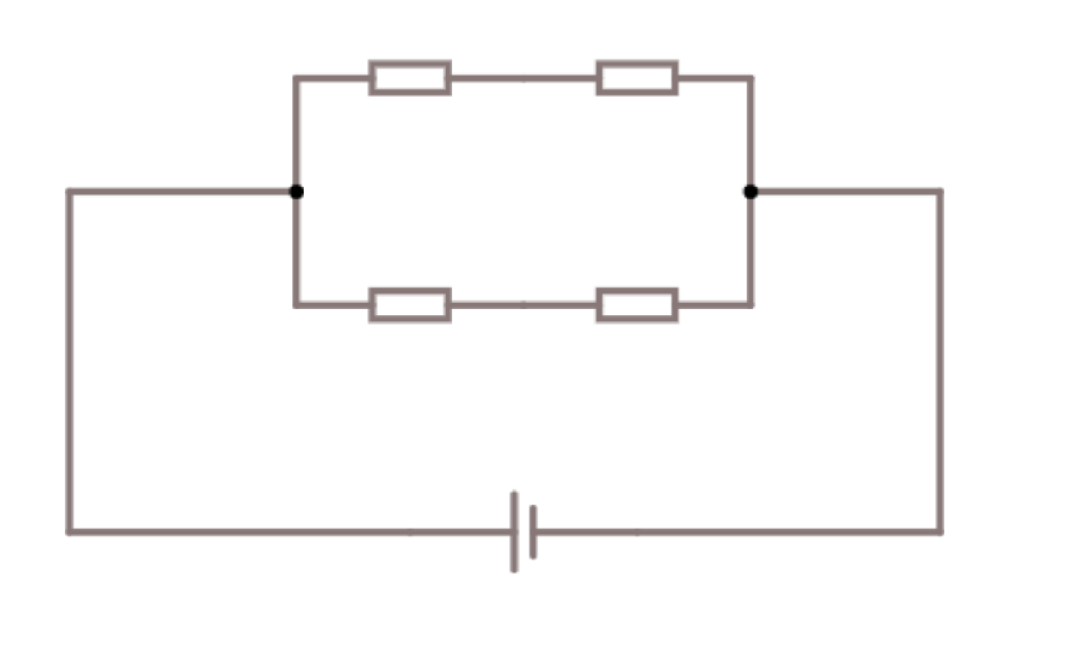

6 Ω

2 Ω

5 Ω

4 Ω

6 V

**P**

**Q**

1. Calculate the total resistance of the circuit. (3 marks)

* Parallel resistance calculation ✓✓
* Answer: R = 4.24 Ω ✓

1. A device **X** is connected to the circuit in series as shown in the diagram.
2. For the circuit to remain operational, should the device be an ammeter or a voltmeter? Circle the correct answer below. (1 mark)

**Ammeter Voltmeter**

✓

1. What would be the reading of the device **X**? (2 marks)

* Ohm’s Law equation ✓
* Answer: I = 1.42 A ✓

1. Calculate the current through point P. (3 marks)

* Using series 6 Ω and 2 Ω resistors (total 8 Ω). ✓
* Ohm’s Law equation ✓
* Answer: I = 0.750 A ✓

1. A student connects points P and Q using a copper wire.
2. Calculate the new total resistance of the circuit. (3 marks)

* First parallel ✓
* Second Parallel ✓
* Total (series) ✓
* Answer R = 4.06 Ω

1. Would the reading of **X** increase or decrease as a result of the change? Explain, without the use of calculations. (2 marks)

* Increased. ✓
* This is because $I∝\frac{1}{R}$.

Because R is reduced, so I increases. ✓



**Question 17 (16 marks)**

The Sun constantly undergoes a series of fusion reactions to produce a large amount of energy. A common series of reactions that occurs within the sun is outlined in the steps below.

1. Two protons fuse together, producing Deuterium and other particles plus energy;
2. Deuterium and a proton fuse, producing Helium-3 and energy;
3. Two Helium-3 nuclei fuse together, producing Helium-4, two protons, and energy;
4. Helium-3 fuses with Helium-4, producing Beryllium-7, which decays and then fuses with another proton to yield two Helium-4 nuclei plus energy.

Use the following data to answer the questions below:

|  |  |  |
| --- | --- | --- |
| **Element** | **Scientific name** | **Mass (u)** |
| ${}_{1}^{1}H$ or ${}_{1}^{1}p$ | Protium/Proton | 1.008 |
| $${}_{1}^{2}H$$ | Deuterium | 2.015 |
| $${}_{1}^{3}H$$ | Tritium | 3.015 |
| $${}_{2}^{3}He$$ | Helium-3 (Helion) | 3.016 |
| $${}_{2}^{4}{He}$$ | Helium-4 | 4.003 |
| $${}_{0}^{1}n$$ | Neutron | 1.008 |

1. For step 3, write the full nuclear equation for the process. (2 marks)

✓✓

1. Use the information above to calculate the energy released, in MeV, for step 3 (part i)). Correct the answer to two significant figures. (5 marks)

* Mass of reactants ✓
* Mass of products ✓
* Mass defect ✓
* Energy equivalent ✓
* Answer E = 12 MeV ✓

1. Calculate the total energy, in Joules, that would be produced from 50.0 Tonnes of Helium-3 undergoing the reaction in Step 3. Correct your answer to two significant figures. (5 marks)

* Number of Helium atoms ✓✓
* Total energy released ✓
* Energy conversion into Joules ✓
* Answer E = 1.9 x 1019 J ✓

1. Helium-4 is more stable than Tritium. Comment on this statement. (2 marks)

* A Helium-4 atom has 2 protons and 2 neutrons

whereas a tritium atom has 1 proton and 2 neutrons. ✓

* The Helium-4 has even ratio of protons and neutrons but

tritium has uneven ratio between protons and neutrons. ✓

1. The Sun’s life span is about 5 billion years. Would the mass of the sun have increased or decreased by then? Explain. (2 marks)

* Decreased. ✓
* The energy released is due to mass defect during the

nuclear fission. This is due to conservation of mass

and mass/energy equivalence. ✓

**END OF SECTION TWO**

**Section Three: Comprehension 20% (36 marks)**

This section has two questions. Answer **both** questions. Answer the questions in the spaces provided.

Suggested working time: 40 minutes.

**Question 18 (24 marks)**

An experiment is carried out by Jamie to investigate how the resistance of a fixed volume of conducting putty varied with its length. This conducting putty is a soft material that can be easily shaped into different lengths.

The experiment apparatus is shown below.

**Ohmmeter**

23 Ω

Metal plate

ℓ

Conducting putty

Jamie conducts the experiment and records the result in the table below. Note that one column is deliberately left blank for further analysis.

|  |  |  |
| --- | --- | --- |
| ***ℓ*** (cm) | ***R*** (Ω) | ***ℓ2*** ( cm2 ) ✓ |
| 6.0 | 25 | 36 |
| 11.0 | 60 | 121 |
| 13.5 | 110 | 182 |
| 17.0 | 180 | 289 |
| 22.5 | 280 | 506 |
| 25.0 | 370 | 625 |

(All values in the column are correct ✓)

(All values are corrected to number sf ✓)

Jamie discovered that the suggested resistivity of the conducting putty, *ρ* (pronounced *rho*), is given by the formula:

$$ρ=\frac{\left(R-R_{o}\right)V}{l^{2}}$$

where ***Ro*** is the resistance of the connecting wires and ***V*** is the volume, in cm3, of the conducting putty.

1. For this experiment: state: (2 marks)
2. Dependent variable: Resistance (in Ω)\_\_\_\_\_\_\_\_\_ \_\_\_\_\_\_\_\_\_\_\_\_✓
3. One controlled variable: Same volume of putty (or similar) ✓
4. Show that the formula can be rearranged as:

$$R=\frac{ρ}{V}l^{2}+R_{o}$$

Show clear working to show how you establish the formula. (3 marks)

* Expansion and cross multiply ✓
* *RoV* is moved over the equal sign ✓
* Divide both sides by V ✓
* Final formula

$$R=\frac{ρ}{V}l^{2}+R_{o}$$

1. Explain why plotting a graph of ***R*** against ***ℓ*** would not enable you to obtain the linear relationship.

(1 mark)

* According to the equation: .✓
* This means that ***R*** against ***ℓ*** is a non-linear relationship.

1. Calculate and record values of ***ℓ2*** in the table on the previous page. Correct your answer to appropriate number of significant figures. (3 marks)

(See page 22)

1. Plot a graph of ***R*** vs ***ℓ2*** on the next page. If you have made a mistake, spare graph paper is on page 31. (5 marks)
2. Use your data to obtain the line of best fit. (1 mark)

(See page 24)

**Graph for Question 18**

Title ✓

Label axes ✓

Labels units ✓

Accuracy/scale ✓✓

LOBF ✓

1. Hence, calculate the gradient of the line of best fit. Include the unit. (4 marks)

* Use two points from the line of best fit. ✓
* Showing rise over run. ✓
* Gradient = 0.58 (± 0.1) Ω cm-1 answer ✓ unit ✓

1. Assume the volume of the putty is 15.0 cm3. Use your gradient in part f) to calculate resistivity of the conducting putty, *ρ*. The unit of the conductivity is not required. (3 marks)

* Relate gradient to the formula: ✓
* Evaluate *ρ* ✓

✓

1. Describe and explain one possible source of error for this experiment. (2 marks)

Possible answers:

* The putty may not exactly cylindrically shaped. ✓
* This will cause uneven distribution of resistance. ✓

**OR**

* Internal resistance of wire. ✓
* The reading is combination of both wire and putty. ✓

(or similar)

**Question 19 (12 marks)**

**Smoke Detectors**

Many smoke detectors use an ionisation chamber and a source of ionising radiation to detect smoke. This type of smoke detector is more common because it is inexpensive and more effective in detecting the smaller amounts of smoke produced by flaming fires.

Inside an ionisation detector is a small amount (0.000200 grams) of Americium-241. The radioactive element americium has a half-life of 432 years.

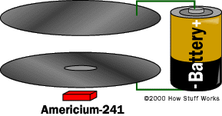Another way to talk about the amount of americium in the detector is to say that a typical detector contains 0.9 micro-curie of Americium-241. A curie is a unit of measure for nuclear material. If you are holding a curie of something in your hand, you are holding an amount of material that undergoes 37,000,000,000 nuclear transformations per second.

Generally, that means that 37 billion atoms in the sample are decaying and emitting a particle of nuclear radiation per second. One gram of the element radium generates approximately 1 curie of activity. Marie Curie, the woman after whom the curie is named, did much of her research using radium.

An ionisation chamber is very simple. It consists of two plates with a voltage applied across them, along with a radioactive source of ionising radiation. (See diagram)

The positively charged particles generated by the americium ionise the oxygen and nitrogen atoms of the air in the chamber. Once these atoms have been ionised, free electrons and positively charged atoms are attracted to the positive and negative plates respectively. The electronics in the smoke detector sense the small amount of electrical current that these electrons and ions moving toward the plates create.

When smoke enters the ionisation chamber, it disrupts this current, the smoke particles attach to the ions and neutralise them. The smoke detector senses the drop in current between the plates and sets off the alarm.

Speaking of alarms, whenever the words "nuclear radiation" are used an alarm goes off in many people's minds. The americium in the smoke detector could only pose a danger if you were to inhale it. Therefore, you do not want to be playing with the americium in a smoke detector, poking at it, or disturbing it in any way, because you don't want it to become airborne.

**Questions**

1. In the text, it repeatedly uses the word “ionisation”. What does this mean? (1 mark)

* An atom loses electrons from another atom

and causing the atom to become a positively

charged particle. ✓

1. The text describes that the americium is used as a substance to emit particles in the smoke detector. What type of radioactive decay would mostly likely be emitted? Explain your answer.

(2 marks)

* An alpha particle. ✓
* In the article it states that the particles are positively

charged. OR ✓

* Because they only need to travel a few cm in air.

1. Hence, express the decay equation for the reaction. (2 marks)

✓✓

1. During a very humid day, a smoke detector might trigger false alarm. Explain why this might occur. (2 marks)

* During the humid day, there are large amount

of water vapour entering the smoke detector. ✓

* The alpha particles can ionise the water vapour

and disturb the current inside the chamber. ✓

* This can trigger the smoke detector.

1. In the text, it states that “a typical detector contains 0.9 micro-curie (µ-curie) of Americium-241”. How many nuclear decays are there in one second? (2 marks)

* Calculation: ✓

37,000,000,000 x 0.9 x 10-6

= 33300 decays

* Answer: 33,300 decays ✓

1. Use the information in the text to calculate the remaining mass, in grams, of Americium-241 used in a smoke detector after 2 000 years. Show all working out clearly. (3 marks)

* Decay calculation ✓✓
* Answer: 8.08x10-6 g or 0.000 00808 g ✓

**END OF SECTION THREE**

**Extra Space**

\_\_\_\_\_\_\_\_\_\_\_\_\_\_\_\_\_\_\_\_\_\_\_\_\_\_\_\_\_\_\_\_\_\_\_\_\_\_\_\_\_\_\_\_\_\_\_\_\_\_\_\_\_\_\_\_\_\_\_\_\_\_\_\_\_\_\_\_\_\_\_\_\_\_\_\_\_\_\_\_\_\_\_

\_\_\_\_\_\_\_\_\_\_\_\_\_\_\_\_\_\_\_\_\_\_\_\_\_\_\_\_\_\_\_\_\_\_\_\_\_\_\_\_\_\_\_\_\_\_\_\_\_\_\_\_\_\_\_\_\_\_\_\_\_\_\_\_\_\_\_\_\_\_\_\_\_\_\_\_\_\_\_\_\_\_\_

\_\_\_\_\_\_\_\_\_\_\_\_\_\_\_\_\_\_\_\_\_\_\_\_\_\_\_\_\_\_\_\_\_\_\_\_\_\_\_\_\_\_\_\_\_\_\_\_\_\_\_\_\_\_\_\_\_\_\_\_\_\_\_\_\_\_\_\_\_\_\_\_\_\_\_\_\_\_\_\_\_\_\_

\_\_\_\_\_\_\_\_\_\_\_\_\_\_\_\_\_\_\_\_\_\_\_\_\_\_\_\_\_\_\_\_\_\_\_\_\_\_\_\_\_\_\_\_\_\_\_\_\_\_\_\_\_\_\_\_\_\_\_\_\_\_\_\_\_\_\_\_\_\_\_\_\_\_\_\_\_\_\_\_\_\_\_

\_\_\_\_\_\_\_\_\_\_\_\_\_\_\_\_\_\_\_\_\_\_\_\_\_\_\_\_\_\_\_\_\_\_\_\_\_\_\_\_\_\_\_\_\_\_\_\_\_\_\_\_\_\_\_\_\_\_\_\_\_\_\_\_\_\_\_\_\_\_\_\_\_\_\_\_\_\_\_\_\_\_\_

\_\_\_\_\_\_\_\_\_\_\_\_\_\_\_\_\_\_\_\_\_\_\_\_\_\_\_\_\_\_\_\_\_\_\_\_\_\_\_\_\_\_\_\_\_\_\_\_\_\_\_\_\_\_\_\_\_\_\_\_\_\_\_\_\_\_\_\_\_\_\_\_\_\_\_\_\_\_\_\_\_\_\_

\_\_\_\_\_\_\_\_\_\_\_\_\_\_\_\_\_\_\_\_\_\_\_\_\_\_\_\_\_\_\_\_\_\_\_\_\_\_\_\_\_\_\_\_\_\_\_\_\_\_\_\_\_\_\_\_\_\_\_\_\_\_\_\_\_\_\_\_\_\_\_\_\_\_\_\_\_\_\_\_\_\_\_

\_\_\_\_\_\_\_\_\_\_\_\_\_\_\_\_\_\_\_\_\_\_\_\_\_\_\_\_\_\_\_\_\_\_\_\_\_\_\_\_\_\_\_\_\_\_\_\_\_\_\_\_\_\_\_\_\_\_\_\_\_\_\_\_\_\_\_\_\_\_\_\_\_\_\_\_\_\_\_\_\_\_\_

\_\_\_\_\_\_\_\_\_\_\_\_\_\_\_\_\_\_\_\_\_\_\_\_\_\_\_\_\_\_\_\_\_\_\_\_\_\_\_\_\_\_\_\_\_\_\_\_\_\_\_\_\_\_\_\_\_\_\_\_\_\_\_\_\_\_\_\_\_\_\_\_\_\_\_\_\_\_\_\_\_\_\_

\_\_\_\_\_\_\_\_\_\_\_\_\_\_\_\_\_\_\_\_\_\_\_\_\_\_\_\_\_\_\_\_\_\_\_\_\_\_\_\_\_\_\_\_\_\_\_\_\_\_\_\_\_\_\_\_\_\_\_\_\_\_\_\_\_\_\_\_\_\_\_\_\_\_\_\_\_\_\_\_\_\_\_

\_\_\_\_\_\_\_\_\_\_\_\_\_\_\_\_\_\_\_\_\_\_\_\_\_\_\_\_\_\_\_\_\_\_\_\_\_\_\_\_\_\_\_\_\_\_\_\_\_\_\_\_\_\_\_\_\_\_\_\_\_\_\_\_\_\_\_\_\_\_\_\_\_\_\_\_\_\_\_\_\_\_\_

\_\_\_\_\_\_\_\_\_\_\_\_\_\_\_\_\_\_\_\_\_\_\_\_\_\_\_\_\_\_\_\_\_\_\_\_\_\_\_\_\_\_\_\_\_\_\_\_\_\_\_\_\_\_\_\_\_\_\_\_\_\_\_\_\_\_\_\_\_\_\_\_\_\_\_\_\_\_\_\_\_\_\_

\_\_\_\_\_\_\_\_\_\_\_\_\_\_\_\_\_\_\_\_\_\_\_\_\_\_\_\_\_\_\_\_\_\_\_\_\_\_\_\_\_\_\_\_\_\_\_\_\_\_\_\_\_\_\_\_\_\_\_\_\_\_\_\_\_\_\_\_\_\_\_\_\_\_\_\_\_\_\_\_\_\_\_

\_\_\_\_\_\_\_\_\_\_\_\_\_\_\_\_\_\_\_\_\_\_\_\_\_\_\_\_\_\_\_\_\_\_\_\_\_\_\_\_\_\_\_\_\_\_\_\_\_\_\_\_\_\_\_\_\_\_\_\_\_\_\_\_\_\_\_\_\_\_\_\_\_\_\_\_\_\_\_\_\_\_\_

\_\_\_\_\_\_\_\_\_\_\_\_\_\_\_\_\_\_\_\_\_\_\_\_\_\_\_\_\_\_\_\_\_\_\_\_\_\_\_\_\_\_\_\_\_\_\_\_\_\_\_\_\_\_\_\_\_\_\_\_\_\_\_\_\_\_\_\_\_\_\_\_\_\_\_\_\_\_\_\_\_\_\_

\_\_\_\_\_\_\_\_\_\_\_\_\_\_\_\_\_\_\_\_\_\_\_\_\_\_\_\_\_\_\_\_\_\_\_\_\_\_\_\_\_\_\_\_\_\_\_\_\_\_\_\_\_\_\_\_\_\_\_\_\_\_\_\_\_\_\_\_\_\_\_\_\_\_\_\_\_\_\_\_\_\_\_

\_\_\_\_\_\_\_\_\_\_\_\_\_\_\_\_\_\_\_\_\_\_\_\_\_\_\_\_\_\_\_\_\_\_\_\_\_\_\_\_\_\_\_\_\_\_\_\_\_\_\_\_\_\_\_\_\_\_\_\_\_\_\_\_\_\_\_\_\_\_\_\_\_\_\_\_\_\_\_\_\_\_\_

\_\_\_\_\_\_\_\_\_\_\_\_\_\_\_\_\_\_\_\_\_\_\_\_\_\_\_\_\_\_\_\_\_\_\_\_\_\_\_\_\_\_\_\_\_\_\_\_\_\_\_\_\_\_\_\_\_\_\_\_\_\_\_\_\_\_\_\_\_\_\_\_\_\_\_\_\_\_\_\_\_\_\_

\_\_\_\_\_\_\_\_\_\_\_\_\_\_\_\_\_\_\_\_\_\_\_\_\_\_\_\_\_\_\_\_\_\_\_\_\_\_\_\_\_\_\_\_\_\_\_\_\_\_\_\_\_\_\_\_\_\_\_\_\_\_\_\_\_\_\_\_\_\_\_\_\_\_\_\_\_\_\_\_\_\_\_

\_\_\_\_\_\_\_\_\_\_\_\_\_\_\_\_\_\_\_\_\_\_\_\_\_\_\_\_\_\_\_\_\_\_\_\_\_\_\_\_\_\_\_\_\_\_\_\_\_\_\_\_\_\_\_\_\_\_\_\_\_\_\_\_\_\_\_\_\_\_\_\_\_\_\_\_\_\_\_\_\_\_\_

\_\_\_\_\_\_\_\_\_\_\_\_\_\_\_\_\_\_\_\_\_\_\_\_\_\_\_\_\_\_\_\_\_\_\_\_\_\_\_\_\_\_\_\_\_\_\_\_\_\_\_\_\_\_\_\_\_\_\_\_\_\_\_\_\_\_\_\_\_\_\_\_\_\_\_\_\_\_\_\_\_\_\_

\_\_\_\_\_\_\_\_\_\_\_\_\_\_\_\_\_\_\_\_\_\_\_\_\_\_\_\_\_\_\_\_\_\_\_\_\_\_\_\_\_\_\_\_\_\_\_\_\_\_\_\_\_\_\_\_\_\_\_\_\_\_\_\_\_\_\_\_\_\_\_\_\_\_\_\_\_\_\_\_\_\_\_

\_\_\_\_\_\_\_\_\_\_\_\_\_\_\_\_\_\_\_\_\_\_\_\_\_\_\_\_\_\_\_\_\_\_\_\_\_\_\_\_\_\_\_\_\_\_\_\_\_\_\_\_\_\_\_\_\_\_\_\_\_\_\_\_\_\_\_\_\_\_\_\_\_\_\_\_\_\_\_\_\_\_\_

\_\_\_\_\_\_\_\_\_\_\_\_\_\_\_\_\_\_\_\_\_\_\_\_\_\_\_\_\_\_\_\_\_\_\_\_\_\_\_\_\_\_\_\_\_\_\_\_\_\_\_\_\_\_\_\_\_\_\_\_\_\_\_\_\_\_\_\_\_\_\_\_\_\_\_\_\_\_\_\_\_\_\_

\_\_\_\_\_\_\_\_\_\_\_\_\_\_\_\_\_\_\_\_\_\_\_\_\_\_\_\_\_\_\_\_\_\_\_\_\_\_\_\_\_\_\_\_\_\_\_\_\_\_\_\_\_\_\_\_\_\_\_\_\_\_\_\_\_\_\_\_\_\_\_\_\_\_\_\_\_\_\_\_\_\_\_

\_\_\_\_\_\_\_\_\_\_\_\_\_\_\_\_\_\_\_\_\_\_\_\_\_\_\_\_\_\_\_\_\_\_\_\_\_\_\_\_\_\_\_\_\_\_\_\_\_\_\_\_\_\_\_\_\_\_\_\_\_\_\_\_\_\_\_\_\_\_\_\_\_\_\_\_\_\_\_\_\_\_\_

\_\_\_\_\_\_\_\_\_\_\_\_\_\_\_\_\_\_\_\_\_\_\_\_\_\_\_\_\_\_\_\_\_\_\_\_\_\_\_\_\_\_\_\_\_\_\_\_\_\_\_\_\_\_\_\_\_\_\_\_\_\_\_\_\_\_\_\_\_\_\_\_\_\_\_\_\_\_\_\_\_\_\_

\_\_\_\_\_\_\_\_\_\_\_\_\_\_\_\_\_\_\_\_\_\_\_\_\_\_\_\_\_\_\_\_\_\_\_\_\_\_\_\_\_\_\_\_\_\_\_\_\_\_\_\_\_\_\_\_\_\_\_\_\_\_\_\_\_\_\_\_\_\_\_\_\_\_\_\_\_\_\_\_\_\_\_

**Extra Graph for question 12**

|  |  |  |  |  |  |  |  |  |  |  |  |  |  |  |  |
| --- | --- | --- | --- | --- | --- | --- | --- | --- | --- | --- | --- | --- | --- | --- | --- |
|  |  |  |  |  |  |  |  |  |  |  |  |  |  |  |  |
|  |  |  |  |  |  |  |  |  |  |  |  |  |  |  |  |
|  |  |  |  |  |  |  |  |  |  |  |  |  |  |  |  |
|  |  |  |  |  |  |  |  |  |  |  |  |  |  |  |  |
|  |  |  |  |  |  |  |  |  |  |  |  |  |  |  |  |
|  |  |  |  |  |  |  |  |  |  |  |  |  |  |  |  |
|  |  |  |  |  |  |  |  |  |  |  |  |  |  |  |  |
|  |  |  |  |  |  |  |  |  |  |  |  |  |  |  |  |
|  |  |  |  |  |  |  |  |  |  |  |  |  |  |  |  |
|  |  |  |  |  |  |  |  |  |  |  |  |  |  |  |  |

**Extra Graph for question 18**

Macintosh HD:Users:wijaya.joni:Desktop:Metric_20mm&2mm_Linear_LightGray&Watermark_MC-Port_Letter.pdf

**Acknowledgements**

**Question 7**

Brain, M. and Elliott, S. (2019). *How Refrigerators Work*. [online] HowStuffWorks. Available at: https://home.howstuffworks.com/refrigerator.htm [Accessed 1 Feb. 2019].

**Question 19**

Brain, M. (2019). *How Smoke Detectors Work*. [online] HowStuffWorks. Available at: https://home.howstuffworks.com/home-improvement/household-safety/smoke.htm [Accessed 12 Jan. 2019].

**WATP acknowledges the permission of School Curriculum and Assessment Authority in**

**providing instructions to students.**